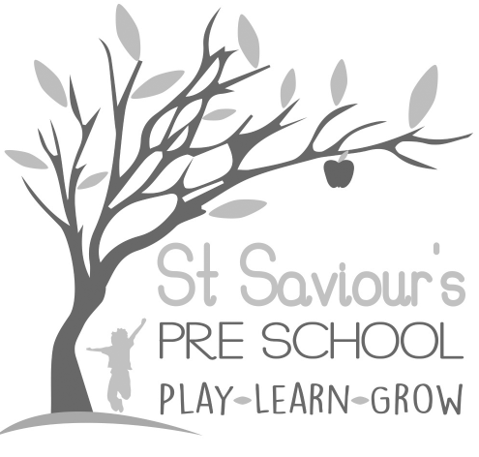
8.4 RISK ASSESSMENT

Written by: Claire Toms and Tina Alder Date: 1.09.22 – reviewed 29.8.25

Policy statement
We believe that the health and safety of children is of paramount importance. We make our setting a safe and healthy place for children, parents, staff, and volunteers by assessing and minimising the hazards and risks to enable the children to thrive in a healthy and safe environment.
The law does not require that all risk is eliminated, but that ‘reasonable precaution’ is taken. This is particularly important when balancing the need for children to be able to take appropriate risks through physically challenging play. Children need the opportunity to work out what is not safe and what they should do when faced with a risk.
Health and safety risk assessments inform procedures. Staff are actively involved in reviewing risk assessments and procedures – they have first-hand knowledge as to whether control measures are effective, and they provide informed views to help update procedures accordingly.
In line with EYFS 2025 requirements, risk assessments are dynamic and ongoing, reflecting the changing needs of children, the environment, and activities provided. Managers ensure that children’s voices are also considered in risk assessments where appropriate, supporting their understanding of risk and safety.

Procedures
- Formal risk assessments are carried out at least annually (September) and reviewed termly, or sooner if significant changes occur.
- Our risk assessment process covers adults and children and includes determining where it is helpful to make some written risk assessments in relation to specific issues, to inform staff practice, and to demonstrate how we are managing risks if asked by parents/carers and inspectors.
- Dynamic (daily) risk assessments are carried out by staff throughout the session to identify and minimise hazards immediately.
- Staff regularly check furniture, equipment, the indoor and outdoor environment and are encouraged to always remain vigilant.
- Any hazards are recorded on the assessment sheet and dealt with immediately where possible. Any matters we cannot deal with immediately are recorded on an Action Plan specifying the action required, the timescales for action, the person responsible for the action and any funding required.
- Some matters are referred to the landlord, in writing.

The setting managers ensure that staff members carry out risk assessments for:
- changing children.
- preparation and serving of food/drink for children.
- children with allergies.
- cooking activities with children.
- supervising outdoor play and indoor/outdoor climbing equipment.
- the use and storage of substances which may be hazardous to health, such as cleaning chemicals.
- visitors to the setting who bring equipment or animals as part of children’s learning experiences and children’s outings.
- the safe use of technology and digital devices, in line with EYFS 2025 safeguarding and online safety guidance.
- transport, travel, and outings, ensuring staff ratios and children’s needs are met.

